

Daftar Publikasi Advetorial Reels Instagram Diskominfo Batola Bulan Oktober 2025
https://www.instagram.com/onlinesinarbarito/reel/DQEYg2CE67h/ | 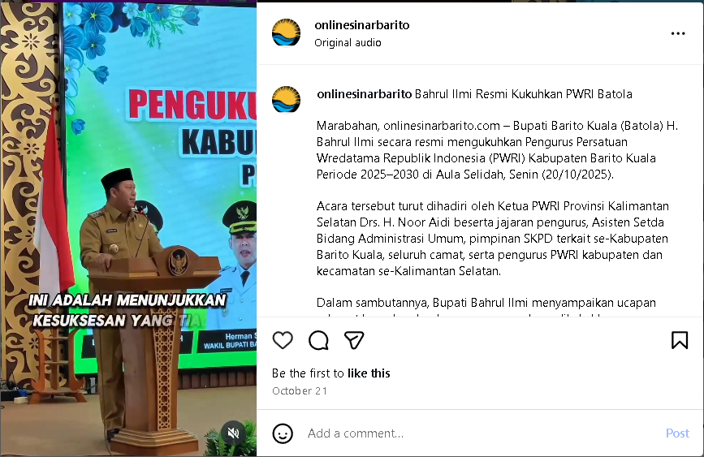
https://www.instagram.com/onlinesinarbarito/reel/DQHfc6XExKB/ | 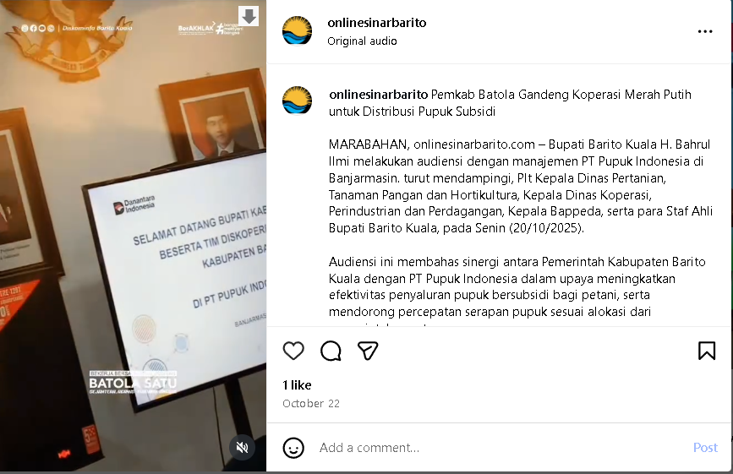
https://www.instagram.com/onlinesinarbarito/reel/DQHgTKKE6_B/ | 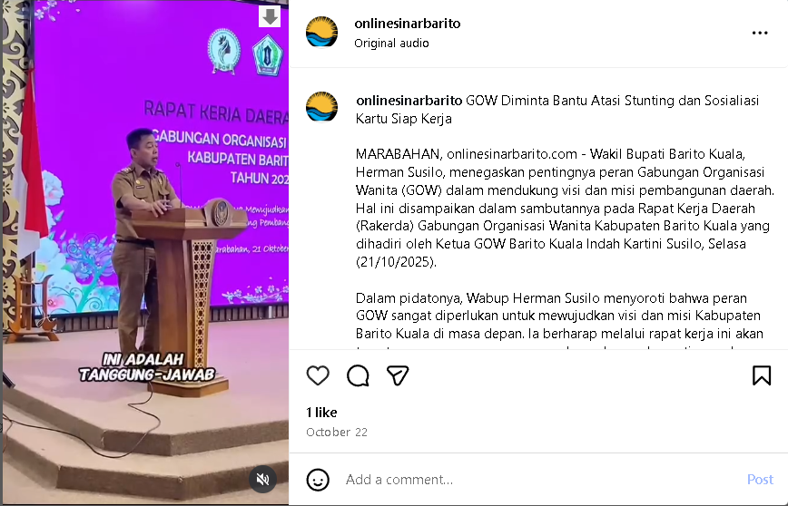
https://www.instagram.com/onlinesinarbarito/reel/DQHhNViE8_p/ | 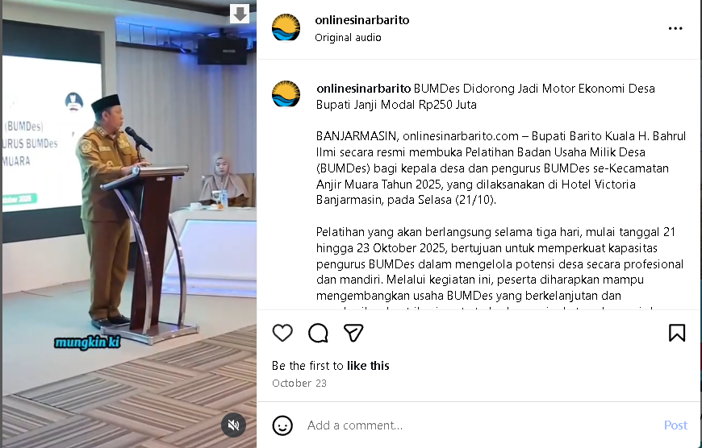
https://www.instagram.com/onlinesinarbarito/reel/DQI7-tWEyVx/ | 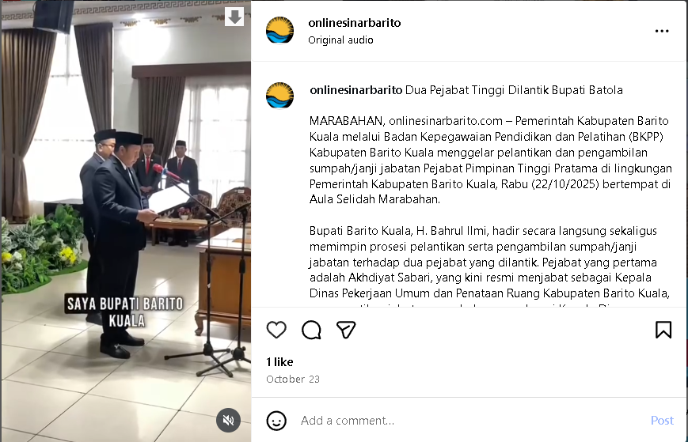
https://www.instagram.com/onlinesinarbarito/reel/DQLEby-E2bS/ | 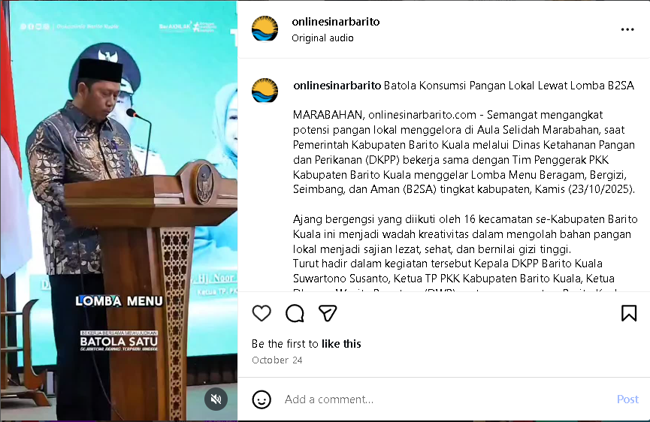
https://www.instagram.com/onlinesinarbarito/reel/DQLK9Q8E5kS/ | 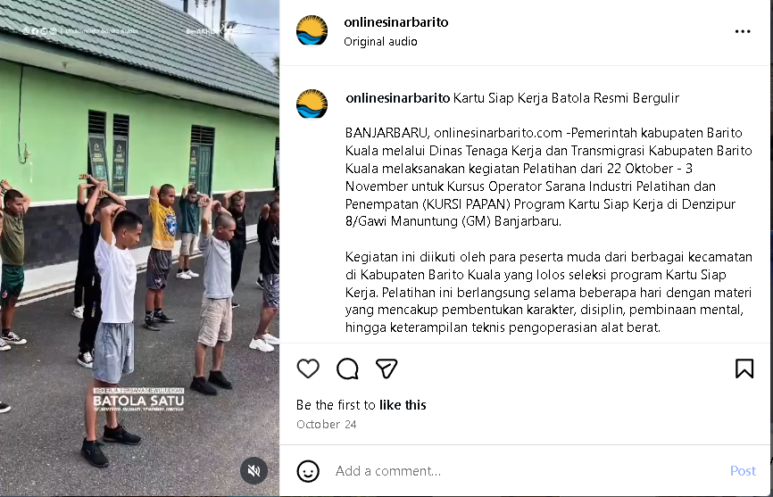
https://www.instagram.com/onlinesinarbarito/reel/DQOsLEEE_Zw/ | 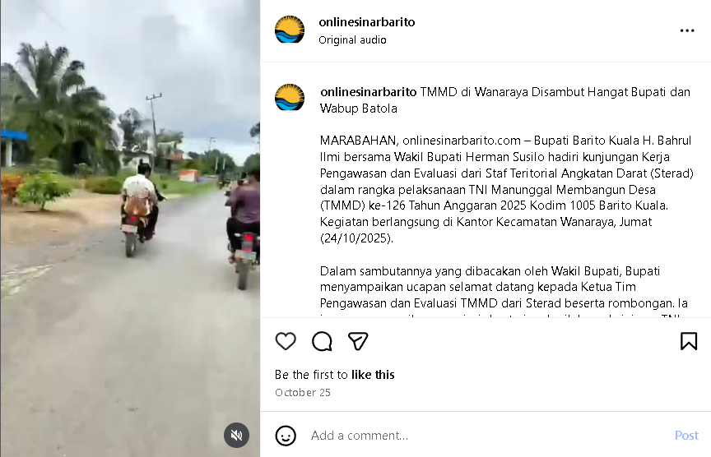
https://www.instagram.com/onlinesinarbarito/reel/DQQFt6jk4RU/ | 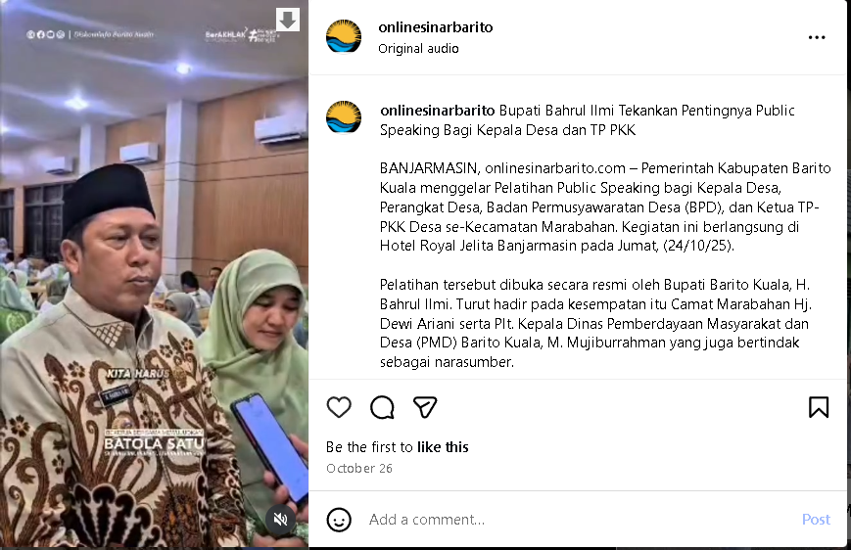
https://www.instagram.com/onlinesinarbarito/reel/DQWDk_DEzX0/ | 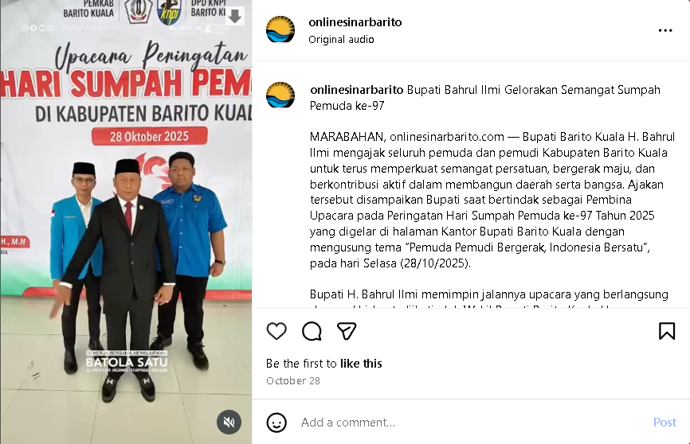
https://www.instagram.com/onlinesinarbarito/reel/DQY2PrCk6Zr/ | 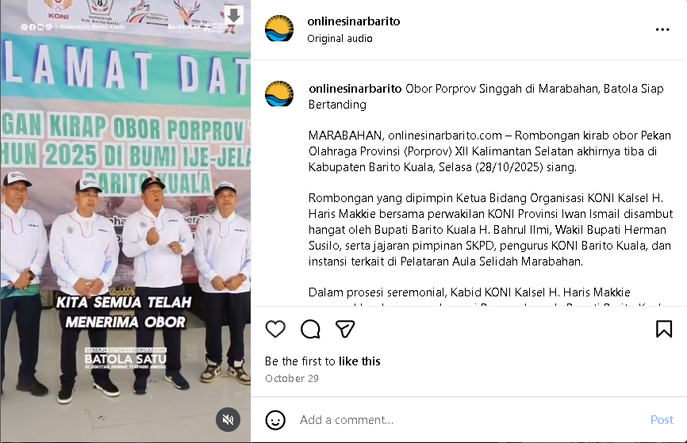
https://www.instagram.com/onlinesinarbarito/reel/DQbaoNEE-Qx/ | 